Project for 2nd Semester of Bachelor of Information Technology

**Home Rental Service**



**Prinsa Maharjan (321025)**

**Subhawana Kunwar (321037)**

**Sudarshan Khatri (321038)**

**KIST college of Information Technology**

**Faculty of Science and Technology**

**Purbanchal University, Nepal**

**February 14,2025**

# STUDENT’S DECLARATION

We hereby declare that the project in the report entitled

**Home Rental System**

Submitted in partial fulfillment of the requirement for the award of Bachelor in Information Technology (BIT) of the Purbanchal University is our orginal work and has not been submitted for award of any other degree or other similar titile or prize.

|  |  |  |  |
| --- | --- | --- | --- |
| S.N. | Name | Registration No. | Symbol No. |
| 1. | Prinsa Maharjan | 05832024392023 | 321025 |
| 2. | Subhawana Kunwar | 05832024472023 | 321037 |
| 3. | Sudharshan Khatri | 05832024482023 | 321038 |

Date**:** 14 February 2025

# RECOMMENDATION

This is to certify that this project entitled **Home Rental System** submitted by **Prinsa Maharjan, Subhawana Kunwar, Sudarshan Khatri** in partial fulfillment of the requirements of the project of Bachelors of Information Technology awarded by Purbanchal University, has been completed under my supervision. I recommend the same for acceptance by Purbanchal University.

Deepak Khadka

Coordinator,BIT

Kist College of Information Technology

14 February 2025

# CERTIFICATE

This project entitled **Home Rental Service** prepared and summited by **Prinsa Maharjan, Subhawana Kunwar and Sudarshan Khatri** has been examined by us and is accepted for the award of the degree of Bachelor of Information Technology by Purbanchal University.

**Sailendra Basnet**

**External examiner Signature Date signed**

**Deepak Khadka**

**Supervisor Signature Date signed**

# ACKNOWLEGEMENT

We are pleased to present the “**Home Rental System**” as our 2nd semester project. We would like to express our sincere gratitude to all those who have supported and guided us throughout the duration of this project.

Firstly, we extend our deepest thanks to our BIT Coordinator **Mr. Deepak Khadka** whose expertise, guidance, and encouragement have been invaluable. His insights and feedback have greatly enriched this project.

We also grateful to our colleagues and team members **Prinsa Maharjan, Subhawana Kunwar, Sudarshan Khatri,** for their active inspiration and cooperation. Our dedication and hard work have been instrumental in the successful completion of this project.

We also thank **Purbanchal University** for designing such a course structure, where we get to learn and implement new things

Lastly, we would like to thank our family and friends for their unwavering support and encouragement throughout this project.

Sincerely,

Prinsa Maharjan

Subhawana Kunwar

Sudarshan Khatri

# Abstract

The “**Home Rental System**” is software that allows customers to see the details of their room or flat in advance, saving valuable time. It offers multiple features to provide a hassle-free experience to a customer and house owner. It’s the software that shifts the traditional system of booking the house rental into an online platform. It helps to manage and store huge numbers of user data sequentially. In the case of our software, customers and house owners directly communicate for services with each other, eliminating brokers with heavy costs. It provides the house owner the ability to display the house details to the customer, and the customer can book the room freely without any cost. Therefore, it is the solution to the traditional system.

The system eliminates the need for brokers or intermediaries, who often charge high commissions, by facilitating direct communication between house owners and customers. The **Home Rental System** enhances transparency, simplifies the booking process, and reduces operational costs, making it a practical solution for modernizing the rental process.

**Keywords:** Home Rental, Online Booking, Direct Communication, House Owners, Customers, Commission-Free, Property Management, User Data Storage, Transparent Process, Modern Rental System

**Table of Content**

STUDENT’S DECLARATION ii

RECOMMENDATION iii

CERTIFICATE iv

ACKNOWLEGEMENT v

Abstract vi

Chapter 1: Introduction 1

1.1 Background 1

1.2 Objectives of the project 2

1.3 Features of the project 2

1.4 Future Implementation of project 3

Chapter 2: Background 4

2.1 Introduction to software/language used 4

2.2 System Recommendations 4

Chapter 3: System design 5

3.1 Data flow diagram (DFD) 5

3.2 Entity Relationship (ER) Diagram 6

3.3 Use Case Diagram 7

3.4 Gantt Chart 8

Chapter 4: Source Code 9

Chapter 5: Conclusion 10

Chapter 6: Bibliography 11

# Chapter 1: Introduction

## 1.1 Background

In today’s world, many individuals find it challenging to allocate time for searching rental properties. Renters often struggle with visiting multiple locations. They can compare the room with budgets and requirements of property. Individual renters can face different problems. Renters often struggle with property owners’ terms and conditions. In big cities, rapid population growth and the search for rental properties have people struggling to search the rental service that helps to find the rental properties.

There is growing demand for an efficient system that simplifies the rental process for both homeowners and renters. The home rental system provides a convenient platform where homeowners can list and renters can browse and inquire from home.

The system allows renters to save time and effort in their property search, making the process more efficient for renters and increasing their chances of renting out properties quickly. By leveraging technology, the Home Rental System improves for both homeowners and renters, making it more accessible and effective.

## 1.2 Objectives of the project

The main objectives are as follows:

* To provide real-time availability of room and flats.
* Foster better communication between landlords and tenants
* Check potential tenants to reduce risks and find reliable renters
* Automate tasks to save time and reduce paperwork.

The general objectives are as follows:

* Create an intuitive and user-friendly interface for both landlords and tenants
* Protect all personal and financial data securely.
* List and manage rental properties easily.

## 1.3 Features of the project

**Customer**

* Account Creation and Profile Management
* Search and Filters
* Property Details
* Booking System

**Houseowner**

* Account Management
* Property listing
* Tenant Management

## 1.4 Future Implementation of project

In the future, improved version of “**Home Rental Service**” will allow much more accessibility to the customer. The project right now is simpler version so it lacks advanced features and is limited in some aspects.

Some future implementations of project are as follows:

* Developing web- based applications or mobile apps.
* More interactive user interface can be designed.
* Online Payment System can be added.
* Maintenance features can be added.

# Chapter 2: Background

## 2.1 Introduction to software/language used

C++ is a general-purpose, object-oriented programming language developed by Bjarne Stroustrup in 1985 at Bell Labs. It is an extension of the C programming language, providing additional features such as object-oriented programming, better type checking, and data abstraction. C++ is widely used for system software, application software, game development, and competitive programming due to its speed, flexibility, and extensive library support. It suitable for a wide range of applications, from system-level programming to game development and large-scale software projects. Some main topic dealt in C++ programming are:

* Variable and constant
* Array and String
* Class and objects
* Inheritance
* Dynamic memory allocation
* File handling

## 2.2 System Recommendations

The minimum requirement of the system is:

**Hardware**

* Pc with intel i5
* 8 MB of RAM or more
* Color monitor
* Hard disk with at least 50 MB of free space

**Software**

* Os windows (windows XP, Windows 7/8/10)/Mac/Linux

# Chapter 3: System design

## 3.1 Data flow diagram (DFD)

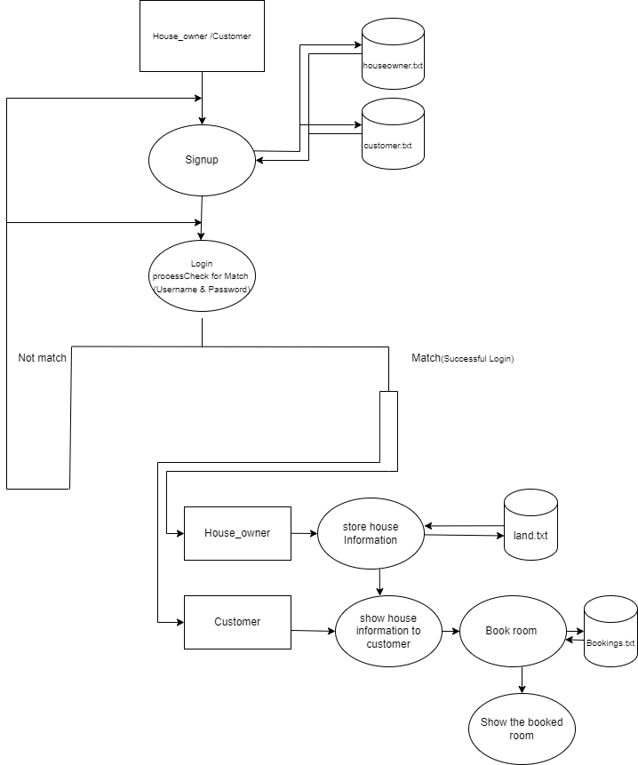

Fig:3.1

## 3.2 Entity Relationship (ER) Diagram

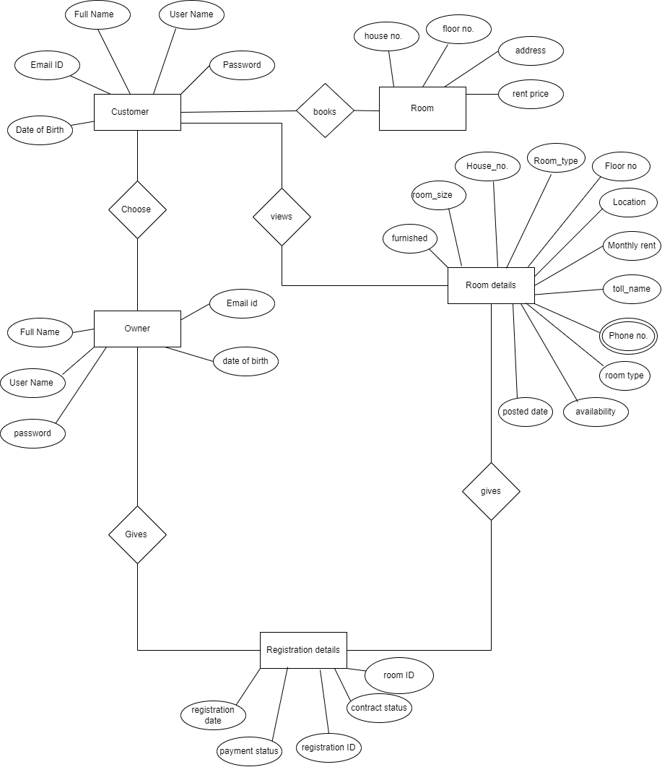

Fig:3.2

## 3.3 Use Case Diagram

# 

Fig:3.3

## 

## 3.4 Gantt Chart

# 

Fig:3.4

# Chapter 4: Source Code

The source code for the project “home rental service” is:

# Chapter 5: Conclusion

We were successfully able to complete this project entitled “home rental service” which is CUI based software application developed using the C++ programming language. software that allows customers to see the details of their room or flat in advance, saving valuable time. While doing this project, we learned about various topics of C++ programming language such as file handling, polymorphism, inheritance and control flow. Creating this project will surely give us a boost of confidence and encourage us to work on further project in the future.

However, it is not a complete system and there are many further improvements that can be done to make it more user-friendly and easier to access and use. Also adding additional features to make it more effective and efficient.

# 

# Chapter 6: Bibliography

[1] GeeksforGeeks. (n.d.). *What is array decay in C++? How can it be prevented?* Retrieved February 12, 2025, from https://www.geeksforgeeks.org/what-is-array-decay-in-c-how-can-it-be-prevented/

[2] Programiz. (n.d.). *C++ namespaces.* Retrieved February 12, 2025, from https://www.programiz.com/cpp-programming/namespaces

[3] Tutorialspoint. (n.d.). *C++ friend functions.* Retrieved February 12, 2025, from https://www.tutorialspoint.com/cplusplus/cpp_friend_functions.htm

[4] TPointTech. (n.d.). *C++ function overriding.* Retrieved February 12, 2025, from https://www.tpointtech.com/cpp-function-overriding

[5] YouTube. (2023, October 14). *C Programming Tutorial* [Video]. YouTube. https://www.youtube.com/watch?v=Eny1B864byY

[6] YouTube. (2023, September 8). *Function Overriding in C++* [Video]. YouTube. https://www.youtube.com/watch?v=tKDPIGdwFSo